**DAILY ONLINE ACTIVITIES SUMMARY**

|  |  |  |  |
| --- | --- | --- | --- |
| **Date:** | **25 June 2020** | **Name:** | **KHATHEEJA SAFREENA.** |
| **Sem & Sec** | **4th sem, 2nd year** | **USN:** | **4al18cs037.** |
| **Online Test Summary** | | | |
| **Subject** | **---------** | | |
| **Max. Marks** | **----** | **Score** | **---** |
| **Certification Course Summary** | | | |
| **Course** | **INTRODUCTION TO R.** | | |
| **Certificate Provider** | **GreatLearning** | **Duration** | **6 hours** |
| **Coding Challenges** | | | |
| **Problem Statement:1 program** | | | |
| **Status: Executed** | | | |
| **Uploaded the report in Github** | | **Yes** | |
| **If yes Repository name** | | **[http://shafreenasharief / lockdown-coding](http://shafreenasharief / lockdown-coding" \o "http://shafreenasharief / lockdown-coding)**  **[http://shafreenasharief / locked-down--certification-course](http://shafreenasharief / locked-down--certification-course" \o "http://shafreenasharief / locked-down--certification-course)**  **[http://shafreenasharief / Daily\_Report](http://shafreenasharief / Daily_Report" \o "http://shafreenasharief / Daily_Report)** | |
| **Uploaded the report in slack** | | **Yes** | |

Certification Course Details: (Attach the snapshot and briefly write the report for the same)

Coding Challenges Details: (Attach the snapshot and briefly write the report for the same)

**CERTIFICATION COURSE SUMMARY:**

Today I started new course **INTRODUCTION TO INFORMATION R** through **GREAT LEARNING** the course is secluded for 6hrs. After the completion of course, certificate will be provided. I completed all the module .I attempted quiz ,which gave me a clear veiw about the topics that were thought and discussed.It consists of 7 modules which also include assessments**.**  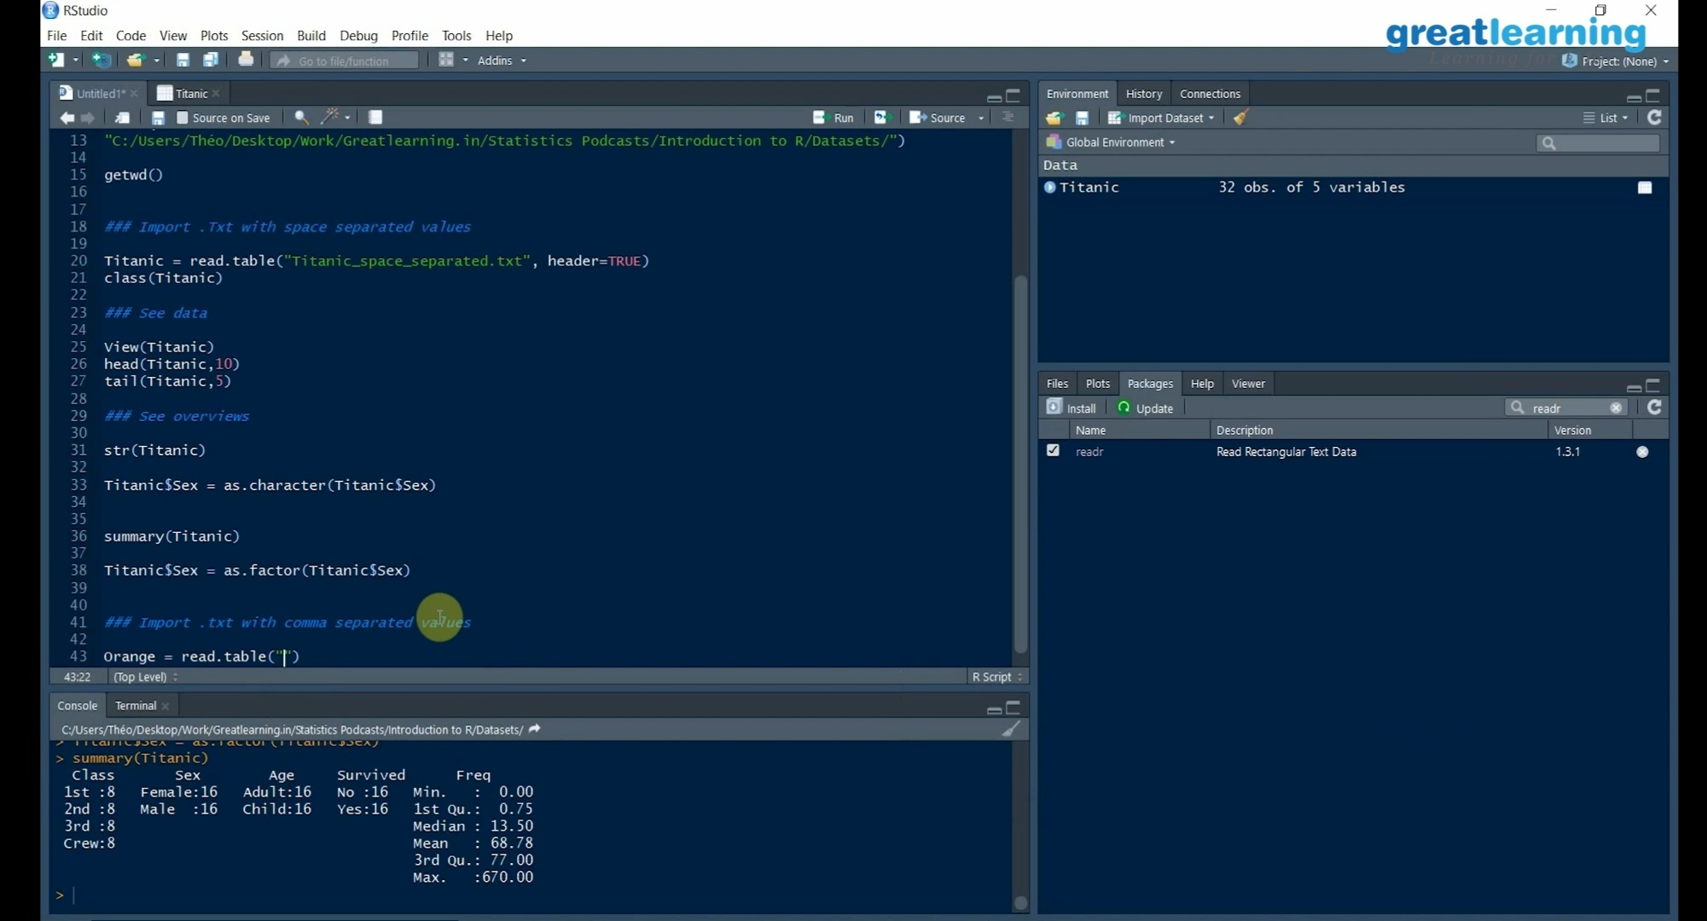

***CODING CHALLENGE :***

Today I solved 1 coding challenge,

**1.Write a C Program to reverse the rows in a 2d Array**

Given a 2D array arr [][] of size M x N integers where M is the number of rows and N is the number of columns. The task is to reverse every row of the given 2D array.

**Example:**

**Input:** arr [][] =  
{ {1, 2, 3},  
{4, 5, 6},  
{7, 8, 9} }

**Output:**  
3 2 1  
6 5 4  
9 8 7

**Input:** arr [][] =  
{ {1, 2},  
{4, 5},  
{7, 8},  
{9, 10} }  
**Output:**  
2 1  
5 4  
8 7  
10 9

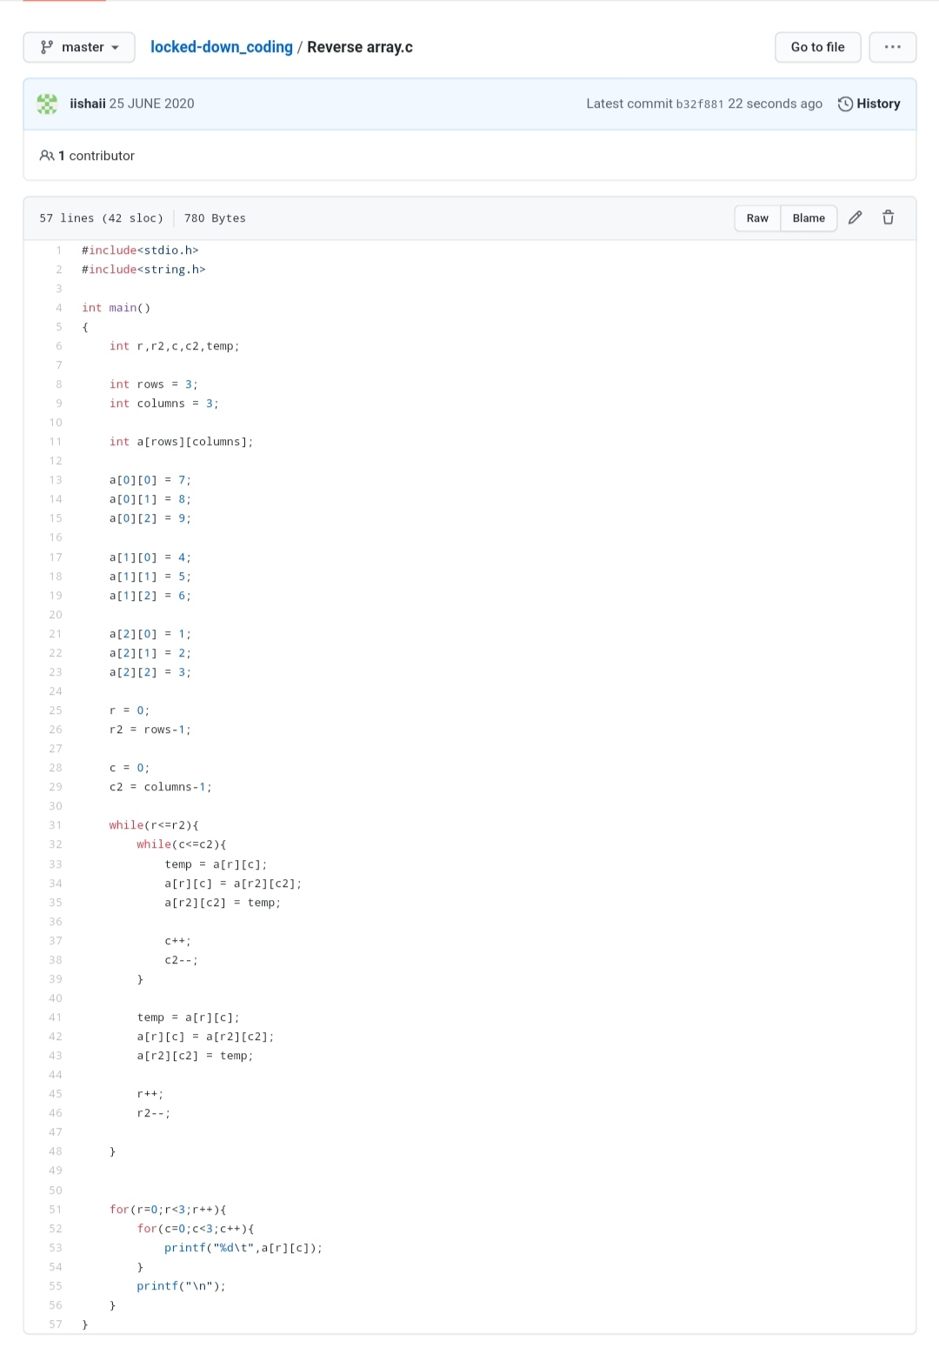

**EXTRA ACTIVITIES**:

Today I attended Online training on C++ from 9:00-11:30 Am, Introduction to C++ and about different programs in the end attended Quiz for 10 min of 30 marks

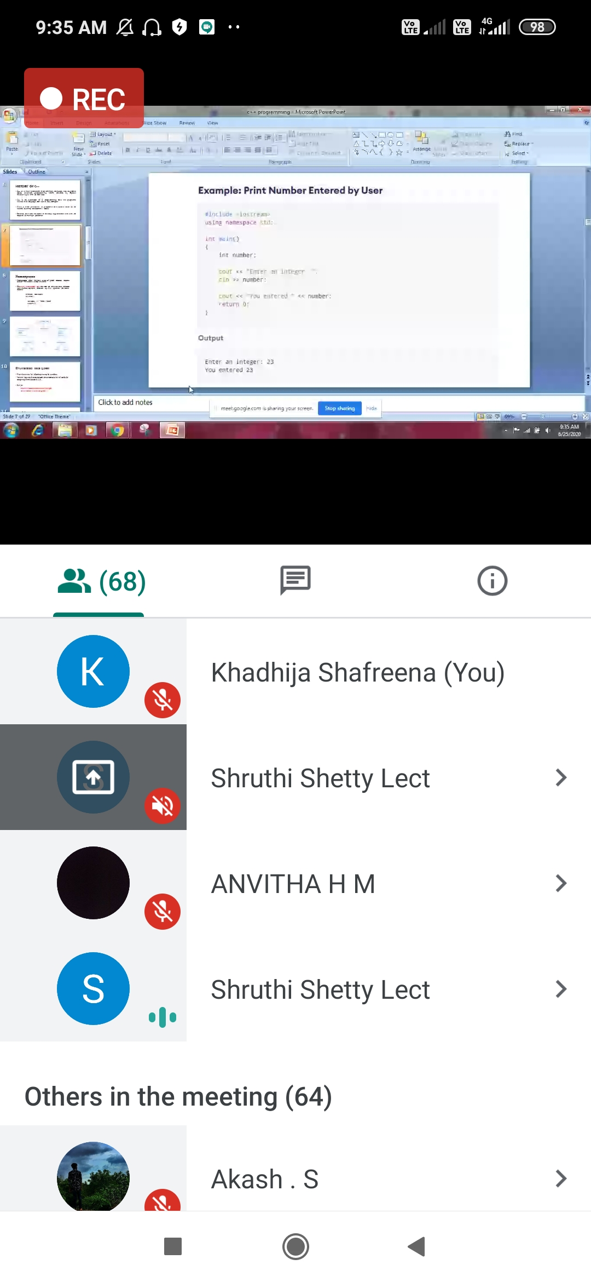

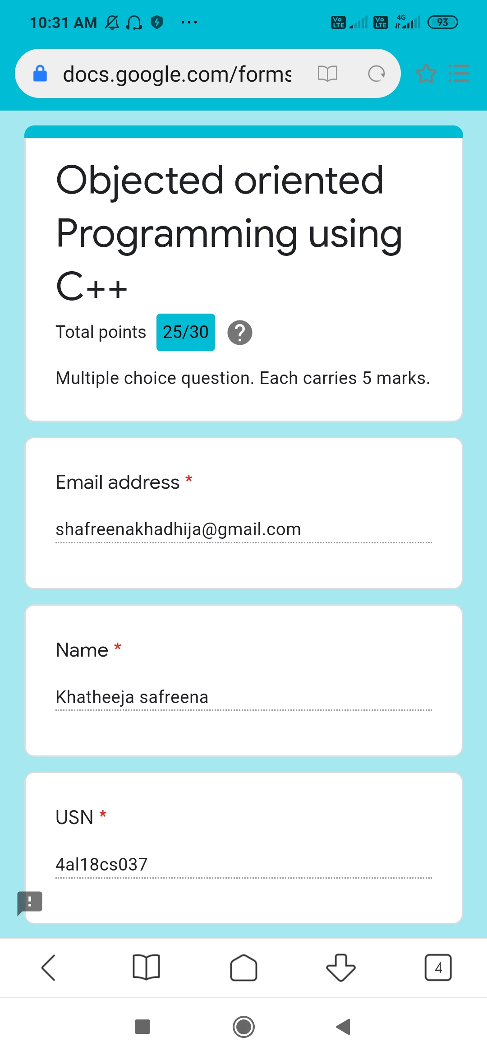

**SOLUTION** : I have uploaded the solution of the above 3 coding problems in my GitHub repository.

[http://shafreenasharief / lockdown-coding](http://shafreenasharief / lockdown-coding" \o "http://shafreenasharief / lockdown-coding)

[http://shafreenasharief / locked-down--certification-course](http://shafreenasharief / locked-down--certification-course" \o "http://shafreenasharief / locked-down--certification-course)

[http://shafreenasharief / Daily\_Report](http://shafreenasharief / Daily_Report" \o "http://shafreenasharief / Daily_Report)